Title 5: RAID and Advanced Filesystem Features in Linux (mdadm, ext4, and XFS Tuning, Performance Test)

What is RAID?

RAID (Redundant Array of Independent Disks) is a technology that combines multiple physical disks into a single logical unit to improve performance, redundancy, or both.
The idea is simple:
Instead of relying on one disk (which can fail or be slow), we use multiple disks together for speed, reliability, or both.
RAID is handled either by:
Software RAID → e.g., mdadm on Linux
Hardware RAID → via dedicated RAID controller card

RAID Levels (Types)
There are many RAID levels, but these are the most common:

RAID Level | Description | Minimum Disks | Storage Efficiency | Fault Tolerance | Performance
RAID 0 (Striping) | Data split (striped) across disks for speed. No redundancy. | 2 | 100% | None | 🚀 High read/write
RAID 1 (Mirroring) | Data duplicated on each disk. | 2 | 50% | 1 disk | ⚡ Good read, slower write
RAID 5 (Striping with Parity) | Data + parity distributed across disks. | 3 | (N-1)/N | 1 disk | ⚡ Good read, moderate write
RAID 6 (Double Parity) | Like RAID 5 but can survive 2 disk failures. | 4 | (N-2)/N | 2 disks | ⚡ Moderate
RAID 10 (1+0) | Combination of mirroring + striping. | 4 | 50% | 1 per mirror | 🚀 Excellent overall

Purpose of RAID

RAID is mainly used for:
Data Redundancy → Prevent data loss if a disk fails.
Performance Improvement → Increase read/write speed.
Larger Logical Volumes → Combine disks into one large storage.
High Availability → Ensure continuous access even after disk failure.

Pros (Advantages)

Benefit | Explanation
Fault Tolerance | Some RAID levels (like RAID 1, 5, 6, 10) protect against disk failure.
Improved Speed | Striping improves read/write performance (especially RAID 0, 5, 10).
Scalability | Easy to expand storage by adding more disks.
Availability | Systems remain operational even if one disk fails (depending on RAID level).

Don’ts / Limitations

Caution | Why
Don’t use RAID as a backup | RAID protects against hardware failure, not accidental deletions or ransomware.
RAID rebuilds can be risky | Rebuilding after a disk failure can stress other disks, potentially leading to a second failure.
RAID 0 has no redundancy | One disk fails → total data loss.
Requires identical disks | Mismatched sizes reduce efficiency.
Software RAID consumes CPU | Minimal, but still a factor compared to hardware RAID.

RAID 5 Example (the one you’re using)
Needs 3 or more disks.
Combines striping (speed) + parity (redundancy).
If one disk fails, you can rebuild from parity.
You get N-1 usable capacity.

Example:
If you have three 512 MB disks →
RAID 5 usable = 512 MB × (3−1) = ~1 GB usable space

Disk Count | Disk Size (Each) | Total Virtual Storage | Notes
3 disks | 500 MB each | ~1 GB usable | Good for basic RAID 5 test
5 disks | 1 GB each | ~4 GB usable | Better for extended practice & benchmarks

Step 1: Creating 3 Disks of 500 MB Each

Before adding 3 disks, the output of lsblk, ls -ld /dev/nvme0n*.it helps us to compare easily, after adding disks.
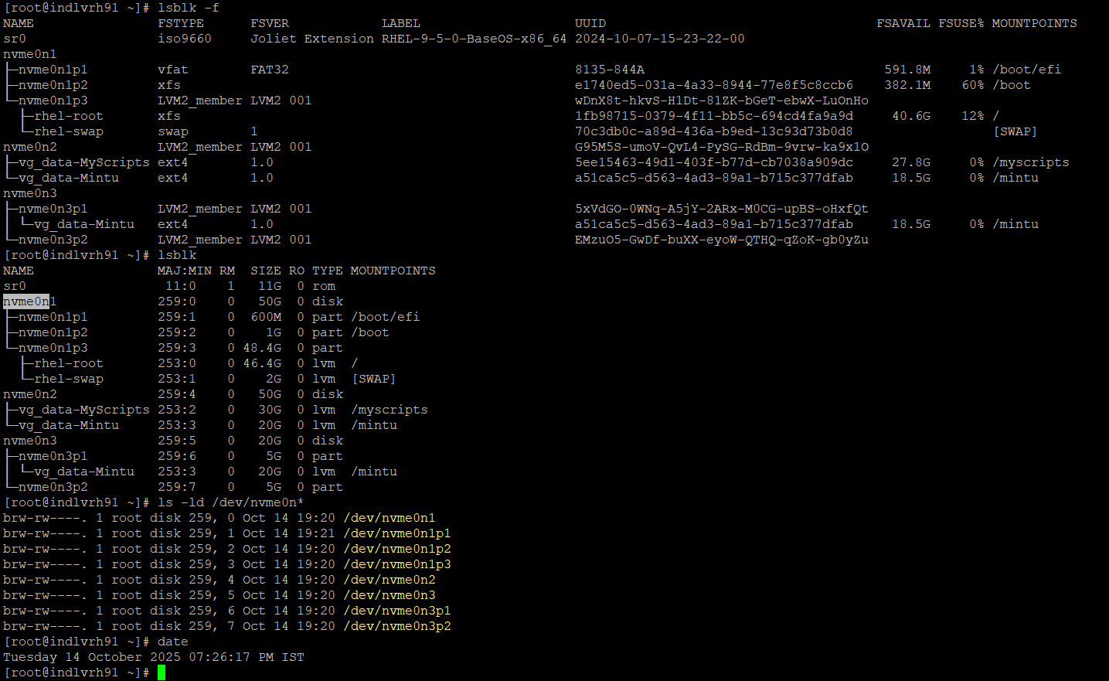

Verify Disks
First, make sure these disks are not in use or mounted.
#lsblk; #blkid

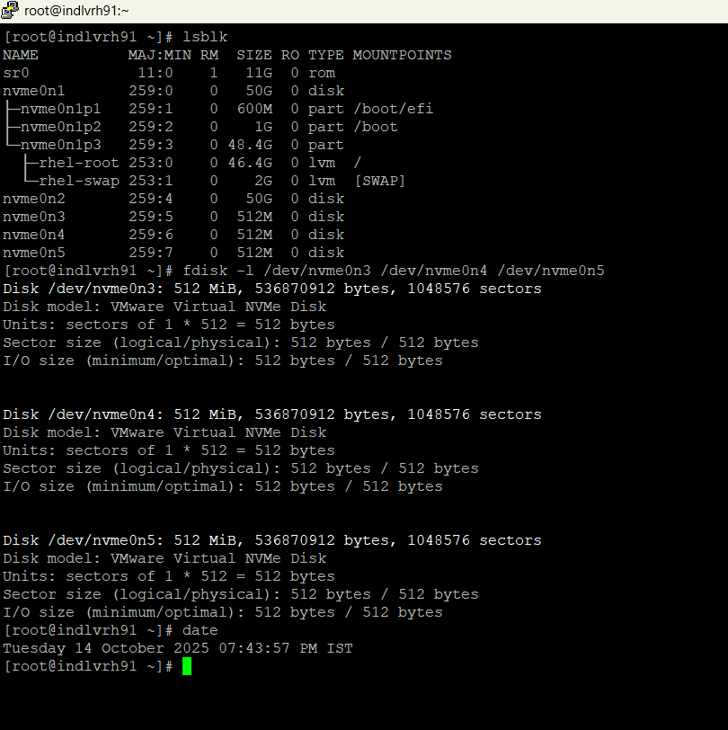

If any of those devices (nvme0n3, nvme0n4, nvme0n5) show partitions or filesystems, wipe them sssclean:

#wipefs -a /dev/nvme0n3
#wipefs -a /dev/nvme0n4
#wipefs -a /dev/nvme0n5
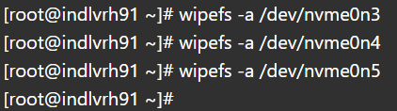
Now, three disks /dev/nvme0n3, /dev/nvme0n4, and /dev/nvme0n5 are completely clean and ready to be used for your RAID 5 array.

Step 2: Install Required Packages

Make sure mdadm (RAID tool) and xfsprogs / e2fsprogs are installed:
#dnf install -y mdadm xfsprogs e2fsprogs
Here, I have already installed all the supported packages at the time of patching.

Using Yum/dnf list installed
# dnf list installed mdadm xfsprogs e2fsprogs

Expected output:
You should see something like this if installed:
Installed Packages
mdadm.x86_64 4.3-4.el9_5 @rhel-9-baseos
xfsprogs.x86_64 6.4.0-5.el9 @rhel-9-baseos
e2fsprogs.x86_64 1.46.5-7.el9 @rhel-9-baseos

Using rpm -q (checks individually)
#rpm -q mdadm
#rpm -q xfsprogs
#rpm -q e2fsprogs

Expected output if installed:
- e2fsprogs → version 1.46.5-7.el9
- mdadm → version 4.3-4.el9_5
- xfsprogs → version 6.4.0-5.el9

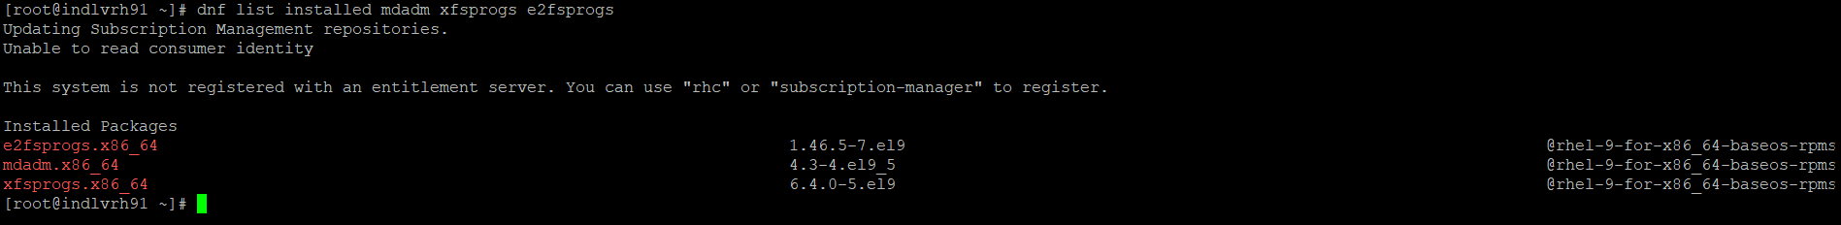

Check if the binaries are available
#which mdadm; #which mkfs.xfs; #which mkfs.ext4

Expected output:
- /usr/sbin/mdadm
- /usr/sbin/mkfs.xfs
- /usr/sbin/mkfs.ext4

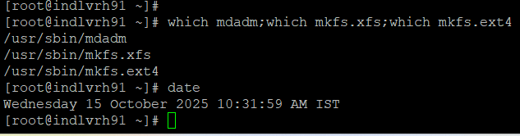

Step 3: Create RAID 5 Array

We’ll use /dev/nvme0n3, /dev/nvme0n4, /dev/nvme0n5.

#mdadm --create --verbose /dev/md0 --level=5 --raid-devices=3 /dev/nvme0n3 /dev/nvme0n4 /dev/nvme0n5

Detail explanation of command

Part | Meaning / Function | Explanation
mdadm | RAID management tool | The Linux utility used to create, assemble, monitor, and manage software RAID arrays.
--create | Create new array | Tells mdadm to create a new RAID device. This erases existing data on listed disks.
--verbose | Detailed output | Enables verbose mode, showing what mdadm is doing — useful for learning or troubleshooting.
/dev/md0 | Target RAID device | The logical RAID device that will be created. You can name it /dev/md0, /dev/md1, etc.
--level=5 | RAID level | Specifies RAID 5 (striped with parity) — combines speed + redundancy, requires ≥3 disks.
--raid-devices=3 | Number of disks | Defines how many physical drives participate in this RAID array. In this case: 3 disks.
/dev/nvme0n3  /dev/nvme0n4  /dev/nvme0n5 | Physical disks | Lists the actual disk devices used to build the RAID. These must be wiped clean before creation.

Quick Calculation
Total Disks | RAID Level | Formula | Usable Capacity | Fault Tolerance
3 × 512 MB | RAID 5 | (N - 1) × Disk Size | (3 - 1) × 512 MB = ~1 GB | Can survive 1 disk failure

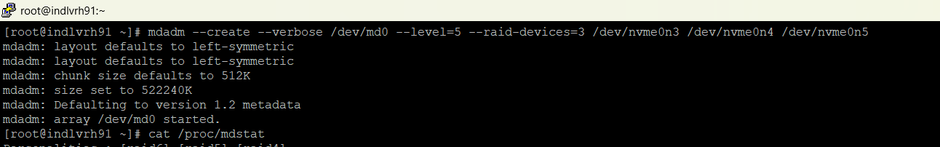

Monitor build progress:
#watch cat /proc/mdstat

Optional Verification After Creation
#cat /proc/mdstat # Shows the RAID progress and sync status
#mdadm --detail /dev/md0 # Shows RAID level, devices, state, UUID
#lsblk # Shows new md device with size

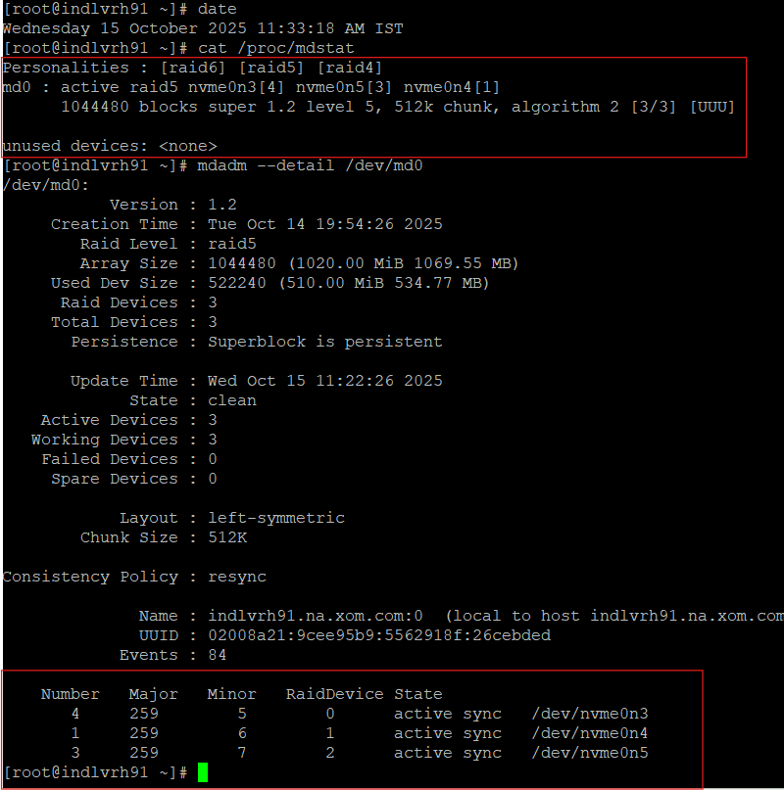
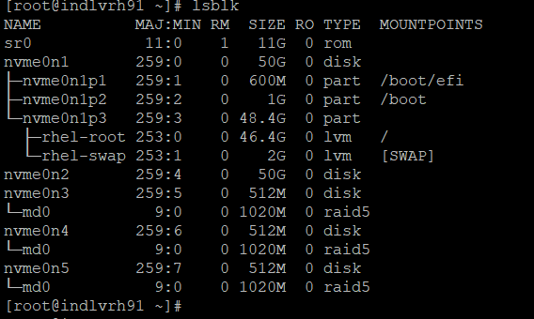

Step 4: Save RAID Configuration (Persistence)

Make sure RAID auto-assembles after reboot:
#mdadm --detail --scan | sudo tee -a /etc/mdadm.conf
#dracut -f
#cat /etc/mdadm.conf

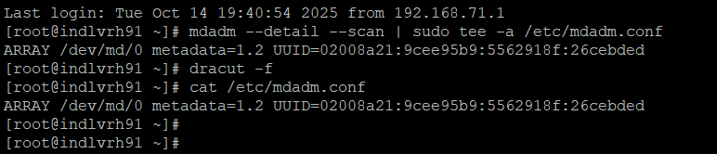

This saves the array info and rebuilds the initramfs image with RAID support.

Step 5: Create a Filesystem

Create a filesystem (ext4 or XFS) on /dev/md0:
Ext4:
#mkfs.ext4 /dev/md0
#mkdir -p /mnt/raid-ext4
#mount /dev/md0 /mnt/raid-ext4
#df -hT /mnt/raid-ext4

XFS (RHEL 9 default), I have chosen.
Format /dev/md0 with XFS
#mkfs.xfs /dev/md0
#mkfs.xfs → creates an XFS filesystem on the RAID device.
By default, it uses the full array size and the default allocation settings.

Create a mount point
#mkdir -p /mnt/raid-xfs
This is where your RAID filesystem will be accessible.

Mount the XFS filesystem
#mount /dev/md0 /mnt/raid-xfs
The RAID array is now ready for use under /mnt/raid-xfs.

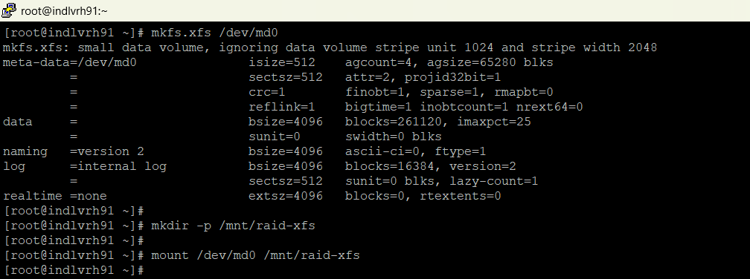

Verify the mount and filesystem
#df -hT /mnt/raid-xfs
#xfs_info /mnt/raid-xfs
#df -hT → shows size, used, and filesystem type.
#lsblk -f → shows RAID device and filesystem info.
#xfs_info → gives detailed info about XFS layout, block size, and metadata.

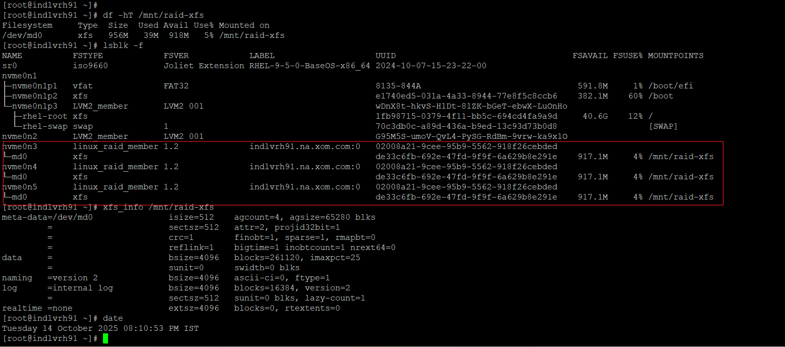

Auto-mount on Boot
Add an entry to /etc/fstab:
#blkid /dev/md0
Copy the UUID of /dev/md0.
Then edit /etc/fstab:
#vi /etc/fstab
Add:
UUID="de33c6fb-692e-47fd-9f9f-6a629b8e291e" /mnt/raid-xfs xfs defaults 0 0
This ensures your RAID XFS mounts automatically after a reboot.

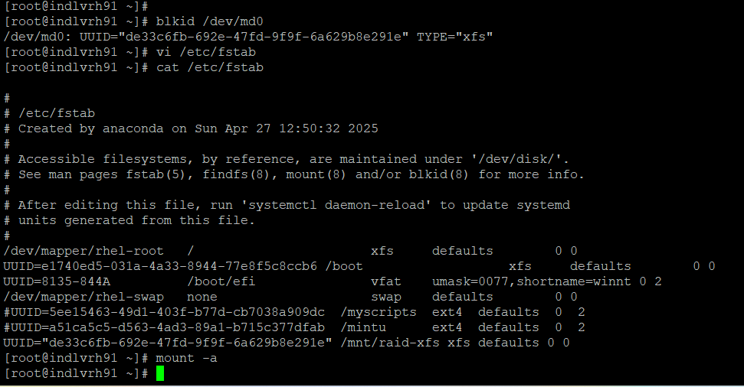

Step 6: Simulate Disk Failure and Rebuild (RAID 5)

Mark one disk as failed:
#mdadm /dev/md0 --fail /dev/nvme0n3
This tells RAID:
“Pretend /dev/nvme0n3 has failed.”
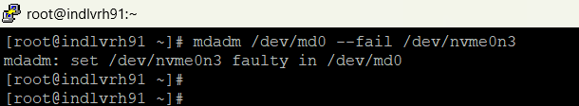

Verify the failure status:
#mdadm --detail /dev/md0
You’ll see something like:
/dev/nvme0n3 -> faulty
/dev/nvme0n4 -> active
/dev/nvme0n5 -> active
and RAID will be in degraded mode.
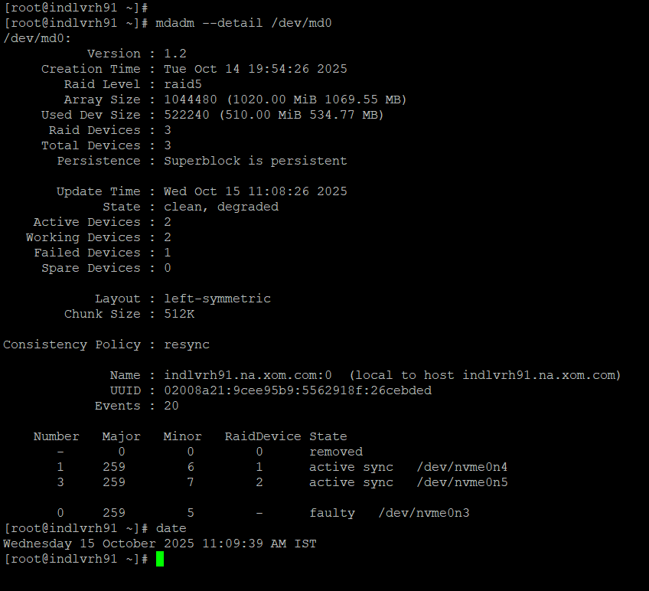

Remove the failed device:
#mdadm /dev/md0 --remove /dev/nvme0n3
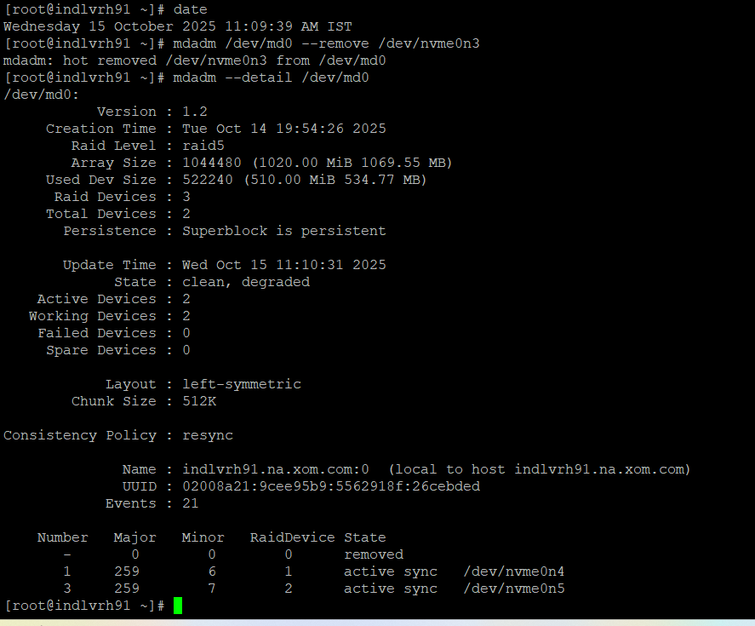

(Optional) Re-add the same device to simulate disk replacement:
#mdadm /dev/md0 --add /dev/nvme0n3
This triggers a rebuild process.
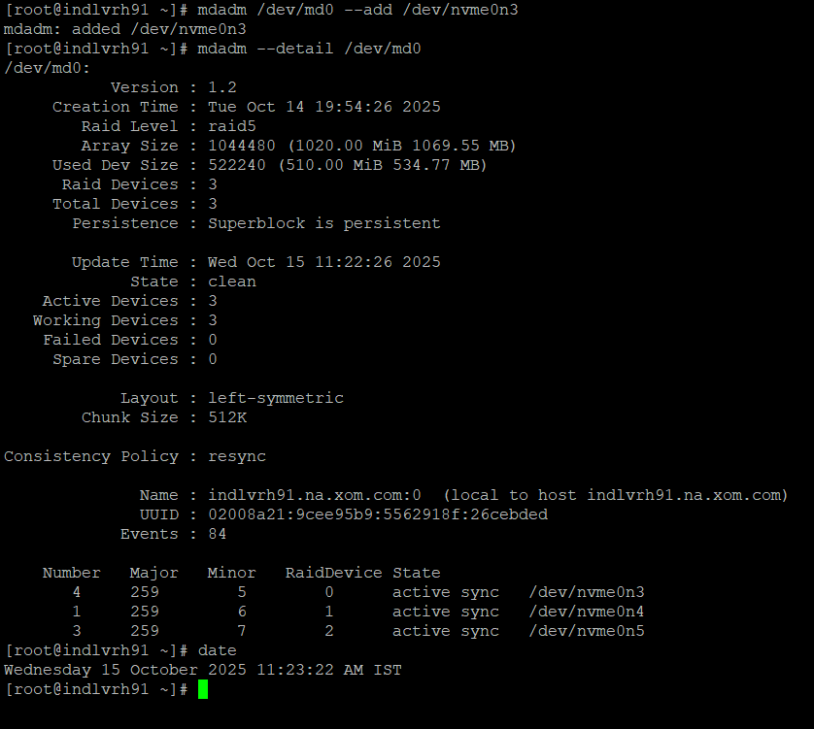

Watch rebuild progress:
#watch cat /proc/mdstat
You’ll see a progress bar as data is rebuilt.
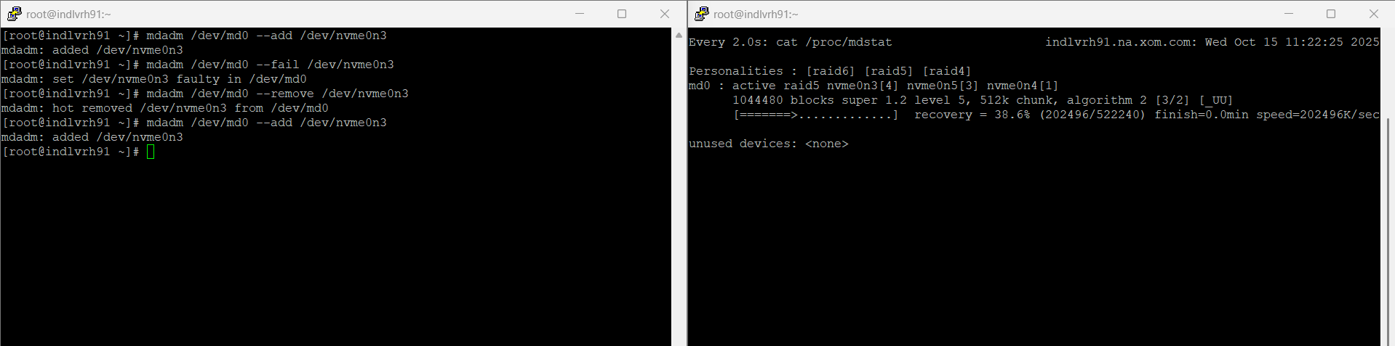

Verify everything is healthy again:
#mdadm --detail /dev/md0
Expected:
State : clean
Active Devices : 3
Working Devices : 3
Failed Devices : 0
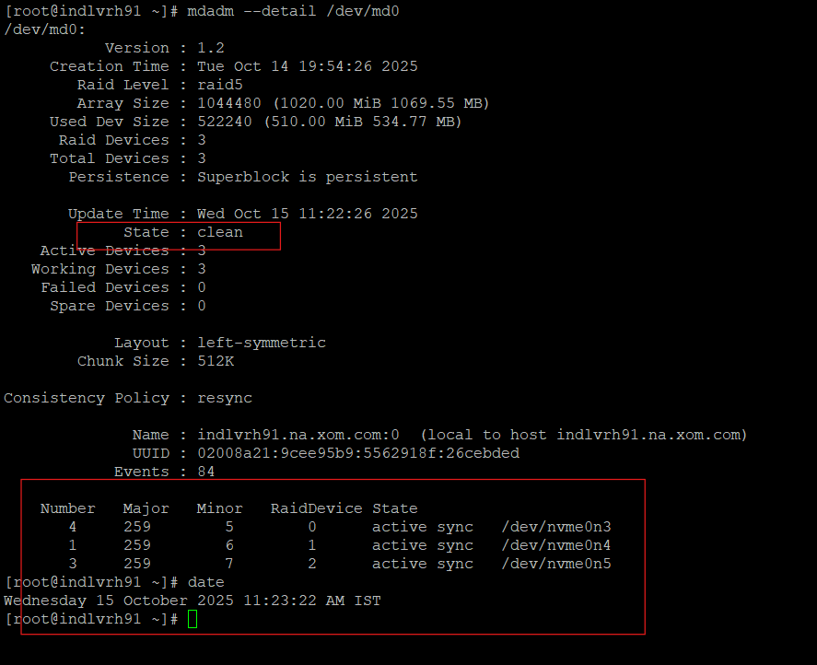

Important Note

Rule | Why
Always fail/remove only one disk in RAID 5 | RAID 5 can survive only one disk failure
Don’t reboot during rebuild | Rebuilding is intensive and must complete
Use cat /proc/mdstat frequently | To monitor rebuild and ensure success

Step 7: Performance Testing

- Write Test (Sequential Write Speed)
#cd /raid-xfs
#dd if=/dev/zero of=testfile bs=1M count=1000 oflag=direct
if=/dev/zero → reads zeroed bytes (simulates data write).

- of=testfile → file to write on RAID.
- bs=1M → block size = 1 MB.
- count=1000 → writes 1000 MB (1 GB).
- oflag=direct → bypass cache to measure actual disk speed.
After completion, it will show MB/s write speed.

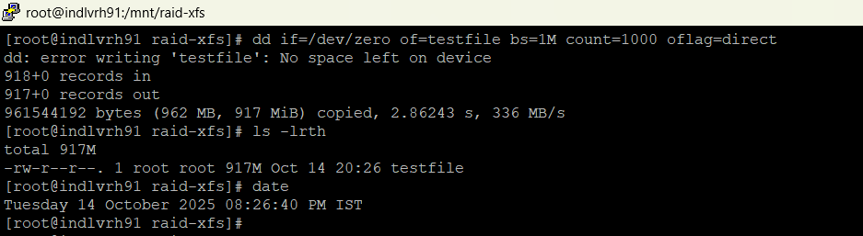

Analysis of Output

dd: error writing 'testfile': No space left on device
918+0 records in
917+0 records out
961544192 bytes (962 MB, 917 MiB) copied, 2.93044 s, 328 MB/s

No space left on device → Expected, because your RAID 5 array is only ~1020 MB in total and you tried to write 1000 MB.
Records in/out → 917 full 1 MB blocks written
Bytes copied → 962 MB actually written.
Speed → ~328 MB/s sequential write speed.
This shows your RAID is functioning and the XFS filesystem is working properly.

- Read Test (Sequential Read Speed)

#dd if=testfile of=/dev/null bs=1M iflag=direct
Reads the file from disk and discards it.
- iflag=direct → bypass cache to measure actual read speed.

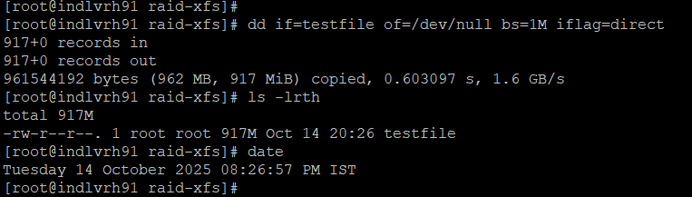

- Clean up the test file (Clearly explained in step 8)
#rm -f /raid-xfs/testfile
Frees space after testing.

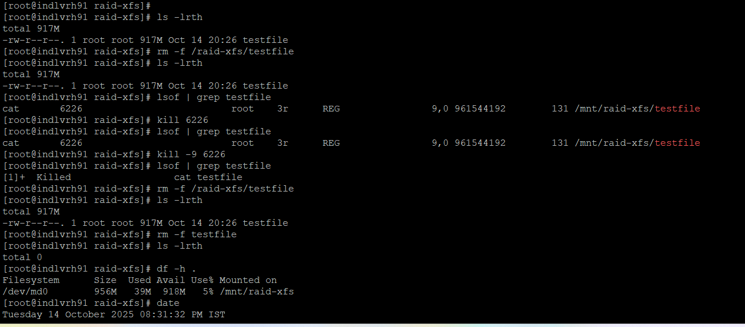

- Use time for benchmarking
time sudo dd if=/dev/zero of=testfile bs=1M count=1000 oflag=direct
Shows the total time it took to write, giving a clear throughput number.

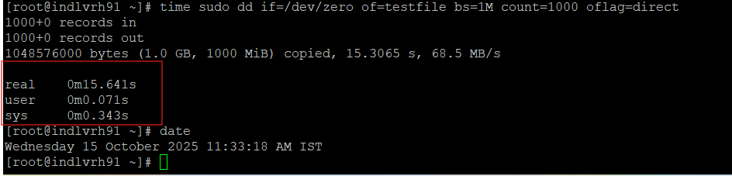

Step 9: File Deletion & Process Lock Behavior

Scenario
Testing what happens when trying to delete a file that is still open by another process on an XFS filesystem mounted on RAID 5 (/mnt/raid-xfs).

Step-by-Step Analysis
- List directory contents
# ls -lrth
Shows one file named testfile, size 917 MB.
Owner: root, Permissions: rw-r--r--
Confirms that the file exists in /mnt/raid-xfs/.

- Try to remove the file
#rm -f /raid-xfs/testfile
Note: you used /raid-xfs (missing /mnt/).
Since the mount point is /mnt/raid-xfs, this path may not actually exist, so the file remains untouched.

- Check open file handles
#lsof | grep testfile
Output:
cat 6226 root 3r REG 9,0 961544192 131 /mnt/raid-xfs/testfile
Meaning:
- Process ID (PID): 6226
- Command: cat
- User: root
- File descriptor: 3r (read-only)
- Size: ~917 MB
File is currently open by the cat process — this is why deletion doesn’t work properly yet.

- Kill the process holding the file
#kill 6226
Terminates the cat process.
However, sometimes the process might linger briefly in memory, so you verify again.

- Recheck
#lsof | grep testfile
Still shows the same entry — meaning process is not yet fully gone.

- Force kill the process
#kill -9 6226
Sends a SIGKILL signal — immediate termination.
Process [1]+ Killed cat testfile confirms success.

- Reattempt file removal
#rm -f /mnt/raid-xfs/testfile
File successfully deleted this time.
Confirmed by ls -lrth → shows total 0 (empty directory).

- Check filesystem usage
#df -h .
Output:
Filesystem Size Used Avail Use% Mounted on
/dev/md0 956M 9.5M 947M 1% /mnt/raid-xfs
Confirms that space used by the deleted file is now reclaimed.
The filesystem is healthy and mounted on /mnt/raid-xfs.
#date
Shows when this verification was done:
Tuesday 14 October 2025 08:31:32 PM IST

Conclusion

We have set up a RAID 5 + XFS setup on RHEL 9 is fully functional and stable.
- The RAID array has been successfully created, verified, and mounted.
- XFS filesystem is operational, formatted, and tested for read/write performance.
- You’ve successfully demonstrated the entire lifecycle of a RAID setup:
  - Disk verification and cleanup
  - RAID creation with mdadm
  - Filesystem creation (XFS)
  - Mounting and verification
  - Performance benchmarking
  - Process/file lock handling
  - Safe cleanup and teardown

